Classification Based on Power Source
Electric Vehicles (EVs)
│
┌──────────────────┼──────────────────┐
│ │ │
HEV PHEV BEV
│ │ │
Hybrid Electric Plug-in Hybrid Battery Electric
Vehicle Electric Vehicle Vehicle
│
│
FCEV
Fuel Cell Electric Vehicle

1. Battery Electric Vehicle (BEV)
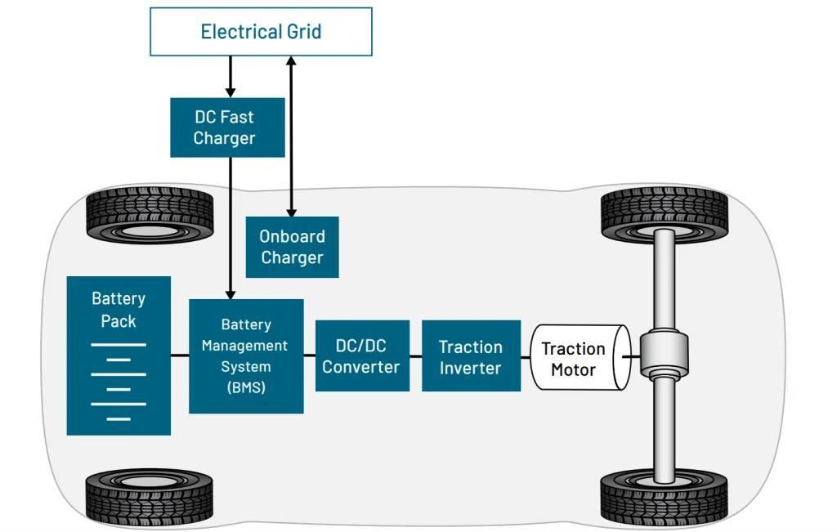
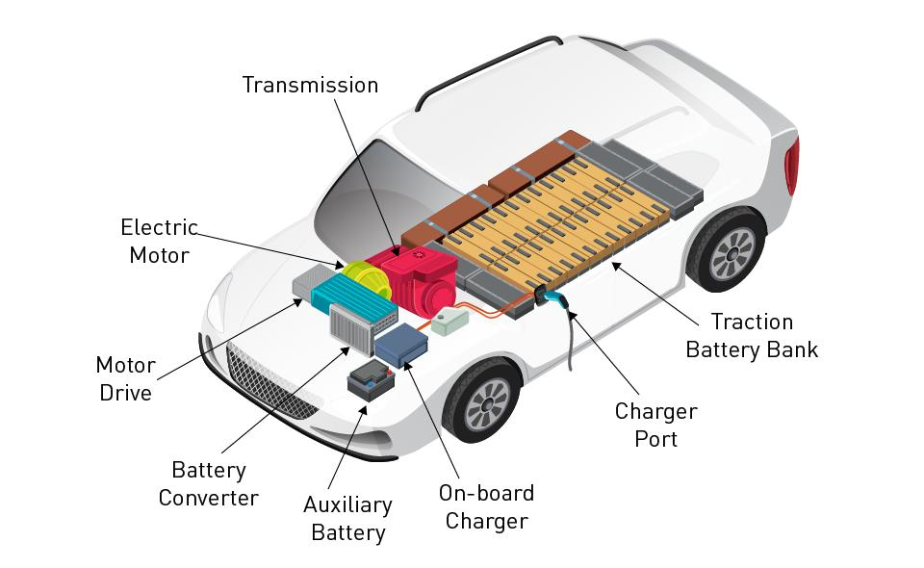
6

Definition
A Battery Electric Vehicle (BEV) is powered entirely by electricity stored in rechargeable batteries. It has no internal combustion engine (ICE) and produces zero tailpipe emissions.

Major Components Explained

Battery Pack
- Stores electrical energy
- Usually lithium-ion
- High voltage (200–800 V depending on vehicle)
- Capacity typically 20–120 kWh

Battery Management System (BMS)
Functions include:
- Cell voltage monitoring
- Temperature monitoring
- Cell balancing
- Over-voltage protection
- Over-current protection
- SOC estimation
- SOH estimation

Inverter
Converts:
Battery DC
│
▼
Three-Phase AC
│
▼
Motor

Electric Motor
Common types:
- Permanent Magnet Synchronous Motor (PMSM)
- Induction Motor
- Brushless DC Motor (BLDC)

Charging
Supports:
- AC Charging (vehicle's onboard charger converts AC to DC)
- DC Fast Charging (external charger supplies DC directly to the battery)

Advantages
- Zero emissions
- High efficiency
- Low maintenance
- Quiet operation
- Instant torque

Disadvantages
- Charging takes longer than refueling
- Higher purchase price
- Range depends on battery capacity
- Battery degradation over time

Examples
- Tesla Model 3
- Tata Nexon EV
- MG ZS EV

END………………

1. EV Charging utility Grid

Overall Architecture
Utility Grid
│
│ AC Power
▼
EV Charging Station
│
┌───────────────────┴───────────────────┐
│ │
▼ ▼
Backend Server Electric Vehicle
│ ▲
│ │
▼ │
Mobile App Charge Cable
│
▼
Payment Gateway

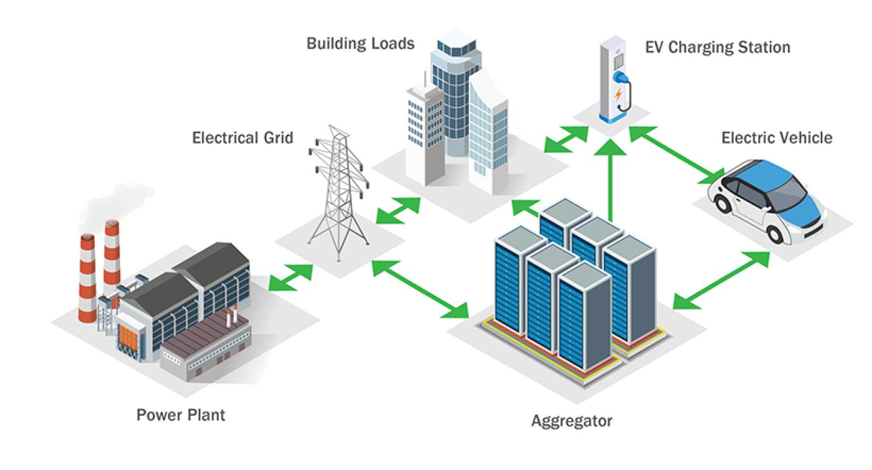
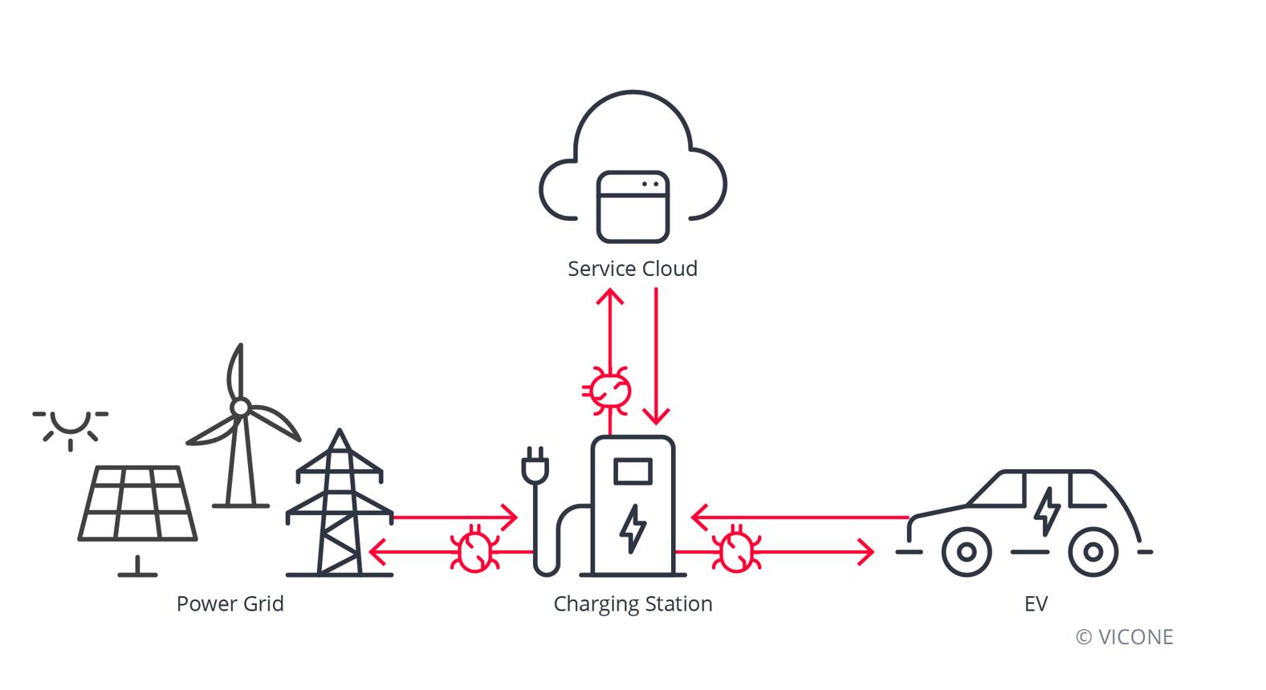

Definition
The Utility Grid is the electrical power infrastructure that supplies electricity to EV charging stations.
It consists of:
- Power generation plants
- Transmission lines
- Distribution substations
- Distribution transformers
- Local electrical network

Main Functions
- Supplies electrical energy
- Maintains stable voltage and frequency
- Handles increasing EV charging demand
- Supports renewable energy integration
- Provides fault protection

Types of Supply

Single Phase
- 230 V AC
- Residential chargers
- Up to approximately 7.4 kW

Three Phase
- 400–415 V AC
- Commercial chargers
- Higher charging power

Hardware Connected to Grid
- Transformer
- Circuit Breaker
- Distribution Panel
- Meter
- Protection Devices

Importance
Without a stable utility grid, the charger cannot operate safely or deliver reliable power.

2. EV Charging Station

6

Definition
The EV Charging Station (also called an EVSE - Electric Vehicle Supply Equipment) safely transfers electrical energy from the utility grid to the electric vehicle.
It is much more than a power outlet—it performs protection, communication, monitoring, and control.

Major Components

Power Section
- AC Input
- Protection
- Contactor
- Power Distribution

Control Board
- MCU (often STM32 or similar)
- ADC
- GPIO
- Timers
- Memory

Communication
- Ethernet
- Wi-Fi
- 4G/5G
- CAN
- RS-485

Protection
- Overcurrent Protection
- Earth Leakage Detection
- Surge Protection
- Emergency Stop
- Temperature Monitoring

User Interface
- LCD
- LEDs
- RFID Reader
- Push Buttons

Responsibilities
- Detect connected vehicle
- Verify charging conditions
- Control contactor
- Measure energy
- Communicate with backend
- Record charging sessions

3. Backend Server

Definition
The Backend Server is a cloud-based management platform that remotely monitors and controls charging stations.

Functions

Station Management
- Online/Offline status
- Remote reboot
- Firmware updates
- Configuration

Charging Management
- Start/Stop charging
- Session logging
- Charging history
- Scheduling

Monitoring
- Fault detection
- Alarm generation
- Diagnostics
- Utilization statistics

Data Storage
- User accounts
- Transaction history
- Energy consumption
- Station logs

Communication Protocol
Most commercial chargers communicate with the backend using:
- OCPP

Example Communication
Charging Station
↓
OCPP
↓
Cloud Server
↓
Database
↓
Operator Dashboard

4. User

Definition
The User is the EV owner or driver who operates the charging station.

User Activities
- Locate nearby charger
- Reserve charging slot
- Authenticate
- Start charging
- Monitor charging
- Stop charging
- Make payment
- View charging history

Authentication Methods
- RFID Card
- Mobile App
- QR Code
- NFC
- Plug & Charge (supported vehicles)

User Expectations
- Safe charging
- Fast charging
- Accurate billing
- Easy payment
- Real-time updates

5. Electric Vehicle
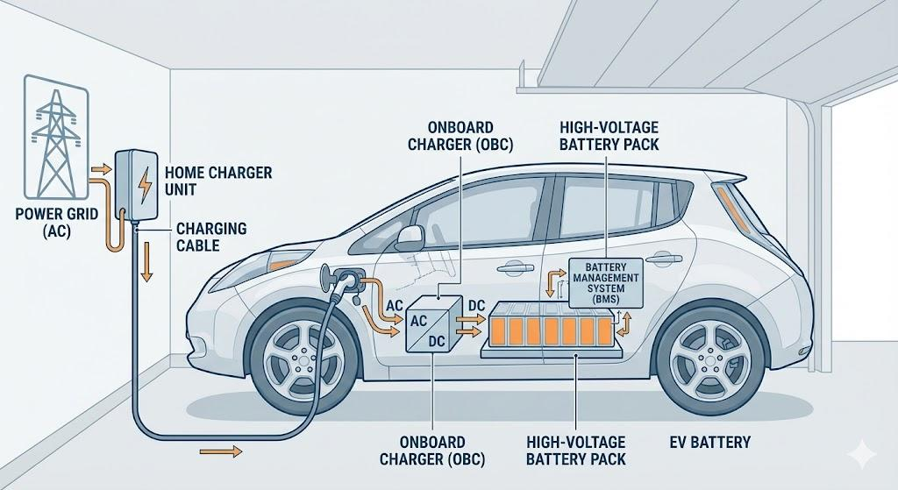

6

Definition
The Electric Vehicle (EV) is the device that receives electrical energy from the charging station.

Charging-Related Components
- Charge Port
- Battery Pack
- Battery Management System (BMS)
- Onboard Charger (for AC charging)
- High Voltage Battery
- Charging Controller

During Charging
The vehicle:
- Detects charger connection
- Exchanges control signals
- Requests charging current
- Monitors battery status
- Stops charging when complete

6. Mobile App

Definition
A Mobile App allows users and operators to interact with charging stations remotely.

User Features
- Find charging stations
- Navigation
- Real-time availability
- Start charging
- Stop charging
- Charging status
- Payment
- Charging history

Operator Features
- Charger health
- Revenue reports
- Fault notifications
- Firmware updates
- Station management

Communication
Mobile App
↓
Internet
↓
Backend Server
↓
Charging Station

7. Payment Gateway

Definition
The Payment Gateway securely processes financial transactions between the user and the charging service provider.

Supported Payment Methods
- Credit Card
- Debit Card
- UPI
- Net Banking
- Digital Wallets
- NFC Payments

Payment Flow
User
↓
Mobile App
↓
Backend Server
↓
Payment Gateway
↓
Bank
↓
Payment Confirmation
↓
Charging Session Starts

Responsibilities
- Secure payment processing
- Payment authorization
- Fraud prevention
- Transaction recording
- Refund processing

Complete Charging Workflow
1. User finds a charger using the mobile app.
│
▼
2. Mobile app requests charger status from the backend server.
│
▼
3. Backend server communicates with the charging station.
│
▼
4. User authenticates (RFID, QR code, app, etc.).
│
▼
5. Backend server validates the user and authorizes charging.
│
▼
6. Charging station performs safety checks and detects the vehicle.
│
▼
7. Charging station closes the contactor and begins charging.
│
▼
8. Energy usage and charger status are continuously sent to the backend.
│
▼
9. User monitors charging progress through the mobile app.
│
▼
10. Charging session ends.
│
▼
11. Payment gateway processes the payment.
│
▼
12. Receipt and charging history are stored and made available to the user.

